Lab 7 Report

Preface

I pivoted my final lab idea after being unable to find a partner and learning that another group was doing a similar automatic gardening system already. My new project is a vehicle that can either be remote controlled by a wearable system or autonomously follow the user. This resulted in two PCBs being submitted for the meantime while I finish deciding to use both, one or the other as the main board for the vehicle system. I am still deciding on parts as a result, but have almost all of the potentially used ones listed in the BOM.

Requirements Document

**1. Overview**

**1.1. Objectives:** The purpose of this project is to design an embedded system and study the topics of power, ADC, DAC, interrupts, UART, displays, and programming for the embedded system. Understanding PCB design and how the components interact with each other in the embedded system are integral to the completion of the lab.

**1.2. Roles and Responsibilities:** The clients are the TA and the Professor. I (the student) will be designing the PCB and programming for this lab.

**1.3. Interactions with Existing Systems:** There will be GPIO analog sensor readings, digital outputs, and power interactions between the PCB and the LaunchPad. Data transfer will occur between the LaunchPad and a wearable device with a NodeMCU using an HC-08 BLE module with UART.

**2. Function Description**

**2.1. Functionality:** The system will consist of a motorized vehicle that can operate autonomously to follow a person or be controlled directly from a wearable device using Bluetooth communication. IR receivers will allow the robot to track a beacon worn by the individual and an accelerometer or flex resistors embedded in the wearable device will enable remote control over the system. LCD displays will relay information to the user about the mode the robot is in, IR sensor data, motors/gears in use, and the inputs it is receiving from the controller.

**2.4. Performance:** Once the final design is assembled, power measurements will be determined based on the current draw of the system using either a power supply or a voltmeter. For initial current approximations, datasheet information will be used and the current draw of each individual component under load will be measured. Performance will be based on how accurately the robot can follow the user and its responsiveness to commands sent via the wearable system.

**2.5. Usability:**

Human interfaces will include the following:

- ST7735R LCD on robot will output visualizations of the sensor data such as IR distance readings, accelerometer data, motor power output. LaunchPad will connect to ST7735R display

- SSD1306 OLED 128x32 pixels on wearable will show basic information (robot mode, commands to send to robot, ect.). This will be connected using SDA and SCL lines to the NodeMCU

- Momentary buttons on both robot and wearable to access different software functions, display information and levels of control

Other interfaces between main components will include the following:

- UART between the HC-08 BLE module and the LaunchPad (115200 baud rate)

-Bluetooth between HC-08 BLE module and Arduino Node MCU on wearable device

- L293NE H-bridge for drive motor control using LaunchPad GPIO pins, L293NE allows for forward, reverse, coasting, and braking

- 711 DC motor for forward and reverse drive controlled through L293NE

- HiTEC HS-422 servo controlled by LaunchPad PWM GPIO pins to steer wheels

- IR detector and LaunchPad GPIO pins for analog readings

- Raw data sent between 6-axis gyro/accelerator to the NodeMCU, which is in turn sent in the raw form to the LaunchPad for processing (do as much on the LaunchPad as possible since it is used for the class)

**3. Deliverables**

**Lab 7 Deliverables:**

**3.1. Reports:** There will be a report for each Lab 7 and Lab 11 stating data measurements and objectives that were completed along with hardware design and code.

**3.2. Outcomes:**

**Pre-preparation (10)** - Requirements Document

You will be judged on the clarity of thought you have about your project. At a very abstract level you should be able to explain your TA what you intend to do and how you intend to do it. You can go through your Requirements document while you explain it to the TA. This will be like a MRD (Marketing Requirements Document) presentation to your TA.

**Preparation (10)** - Schematic

By the prep-day you should have a very clear idea about your project. So you should be able to describe the lower level interface of your system. You can go through your schematic and BOM while you explain it to the TA. While you do this you would also like to point out your hardware and software design boundaries. This will be like a PRD (Product Requirements Document) presentation to your TA.

**Check out (30)** - PCB layout

Complexity (10) - You should be able to convince your TA that you have taken up a challenging project. Indicate the cool features of your project and the effort you will have to put in to make it work. Be as specific as possible.

Planning (10) - For every big project it is important to plan things out ahead of time. Break up your work into smaller steps and assign a deadline to each one. Remember to adhere to them.

Prototyping - Although as part of this lab you need to prototype your system before you finalize your PCB layout, your grade on this will be reflected in Lab 8 where you design the software for the system and do a much more precise prototyping.

PCB Layout (10) - Due with Checkout

**Oral Questions (10)**

**Timely submission (10)** - The PCB order process has to be done in bulk (for the discount) and on time (so that we get back the PCB on time). So it is very important you adhere to the deadline.

**Report (30)**

Requirements Document (10) - Due with Pre-Prep

Schematic (10) - A significant amount of this grade will be on how you plan to debug your board

Test points

Proper use of the logic analyzer

Professor’s signature on the SCH file (10) - Due with Lab submission along with a copy of the above

**Lab 11 Deliverables:**

A) Objectives

2-page requirements document

B) Hardware Design

Detailed circuit diagram of the system (from Lab 7)

C) Software Design (no software printout in the report)

Briefly explain how your software works (1/2 page maximum)

D) Measurement Data

Include data as appropriate for your system. Explain how the data was collected.

E) Analysis and Discussion (none). The YouTube video is required

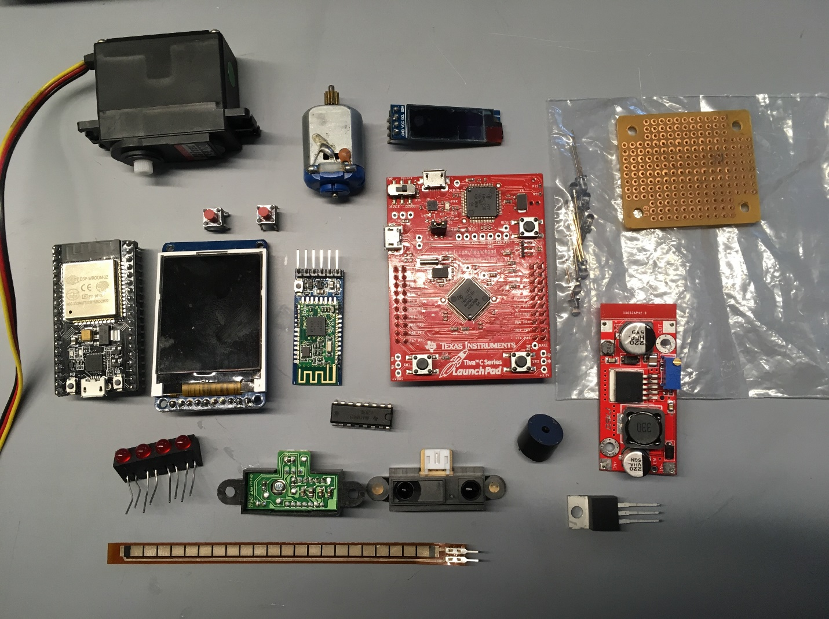Below is a picture of some of the main components/interfaces that will possibly be used:

Measurements

Total cost to produce the system (cost of all components minus ones provided by class/lab) is approximately $59.06 at current market prices. I currently own all of the required parts, so there is no wait time or shipping costs associated with starting the manufacturing process of the embedded system. See Lab 7 BOM for complete details.

For the vehicle system, the peak current draw based on individual component values under load is approximately:

* 80mA for the LaunchPad
* 35mA for the HC-08
* 55mA for the ST7735R
* 250mA-300mA for the HS-422 servo (high load)
* 1.6A for the 711 brushless DC motor at max
* 15mA x 4 SHARP QH3031 IR Receivers
* 47mA for worst case logic and output levels for the L293NE H-bridge

Thus, the total approximate current draw for the vehicle system alone is 2.177 A at full load. To last close to one hour under full load at the class Expo, a 5000mAh battery would be required.

The peak current values for components used in the wearable device is approximately:

* 67mA for the NodeMCU with BLE microcontroller
* 20mA for the SSD1306 OLED
* 18mA x 2 IR diodes as a beacon for robot to follow
* 15mA for the accelerometer

The total approximate current draw is 138mA for the wearable system. To last the duration of the class Expo, a 250mAh battery would suffice.